STOP MEANS STOP

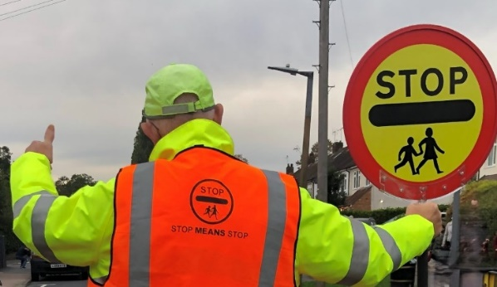
If you are fortunate enough to have a School Crossing Patrol at your school, you may notice they are wearing a bright orange ‘STOP MEANS STOP’ tabard this October/November.
The ‘STOP MEANS STOP’ campaign is run to remind drivers how important it is to stop for a patrol, helping to keep you safe every time you cross the road.
If you are driving and your School Crossing Patrol requests that you stop, please remember they are there to keep your children safe and do a great job, turning out in all weathers.
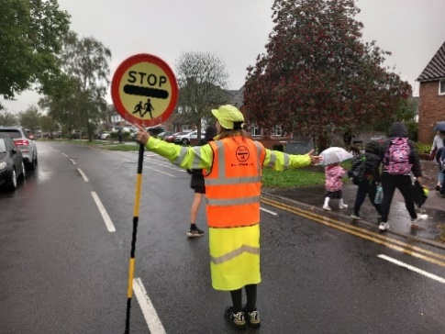
The patrol stands central in the road until everyone is safely on the other side, so please wait until they leave the road and are safely back on the footpath before driving away. This may seem like ages but in fact it is usually less than a minute.

Now the clocks have changed the mornings and afternoons are darker. Using the patrol is the safest place to cross, as they can be seen from a distance in their bright coats and hats.

YOUR SUPPORT IS VERY MUCH APPRECIATED, THANK YOU

