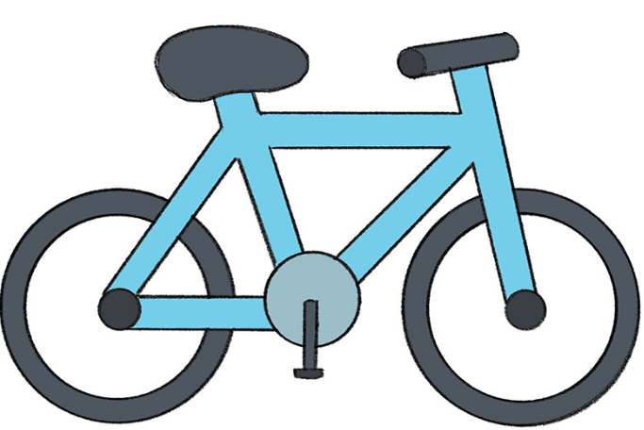
Does your child want to learn to ride a bike? Ready to boost their cycling skills? Missed out on Bikeability training?
If you answered yes to any of these, we’ve got you covered this February half term!
Cycle training sessions are running across Hertfordshire, with options for all ages and abilities. Check out what’s happening near you:
🚲 Watford Cycle Hub
King George V Playing Fields, Tolpits Lane
More details: www.watfordcyclehub.org.uk
🚲 Stevenage Cycling Hub
Fairlands Valley Park, Stevenage
Find out more: www.stevenagecyclinghub.co.uk
🚲 St Albans Cycle Hub C.I.C
Cottonmill Estate, St Albans
Course info: www.stalbanscyclehub.co.uk
🚲 SEND Cycling Courses
Various locations across Hertfordshire during most school holidays
In partnership with the Herts Disability Sports Foundation, we offer specialist 1 to 1 cycle training for riders with additional needs.
Find out more: www.hdsf.co.uk/find-an-activity/cyclingactivities/

