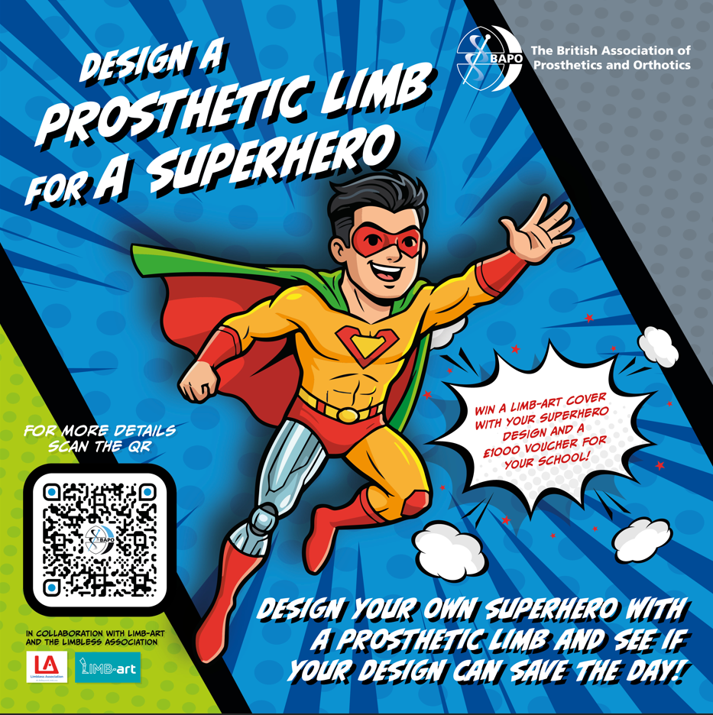
We’re excited to invite your school to take part in a new national STEM competition that brings creativity, inclusion, and real-world careers together.

The British Association of Prosthetics and Orthotics, in collaboration with the Limbless Association, and LIMB-art, is launching “Design a Superhero with a Prosthetic Limb” for Key Stage 2 pupils across the UK.

This engaging project challenges students to design a prosthetic limb for a superhero, helping them explore engineering, design thinking, and the human impact of healthcare careers. Along the way, pupils also learn about the role of prosthetists and how science and creativity combine to change lives.

Who can take part?
All UK primary school pupils in Key Stage 2.

Prizes

- The winning student or group will see their design turned into a real LIMB-art cover.
- The winning school will receive a £1,000 voucher to spend on resources or student activities.
- The winning entry will also be featured in BAPO’s national magazine and online platforms.

Key dates

- Entries close: 29 May 2026
- Winner announced by: 30 June 2026

Entries are submitted by schools via a simple online form, and pupils can enter using drawings, models, or digital designs.

All competition materials, including lesson-friendly resources and full guidance, are available in the competition pack.

For more information or to get started, please see the document attached and visit www.bapo.com or contact enquiries@bapo.com.

