New Google Classroom sign-in – for home devices

Open your browser and search ‘Google Classroom’, or open Google Classroom app.
Select ‘sign in’ and enter child’s username e.g. childsname@lmarston.co.uk
The following screen will appear.
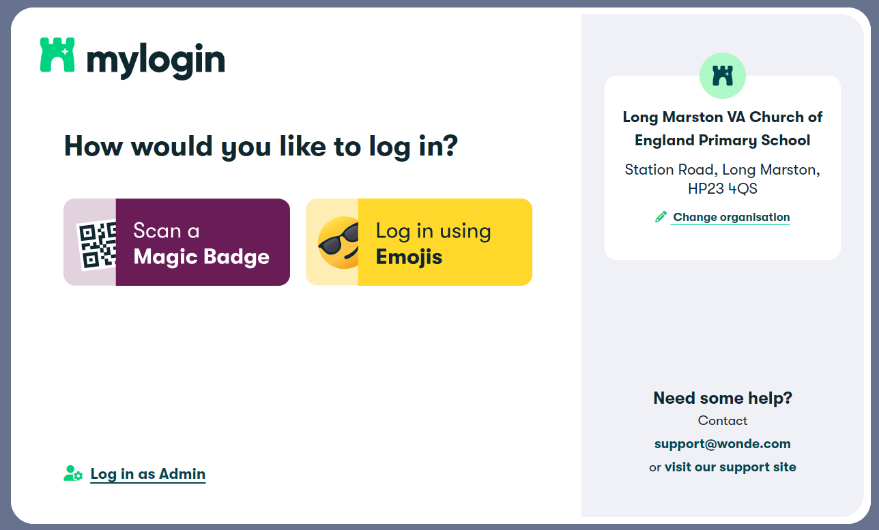

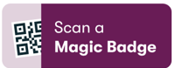
OPTION 1
- If your device has a working camera, select
- Hold your child’s QR code in front of the camera, so that it sits inside the green box on the screen. You will see a tick when the code is read successfully.
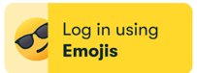
OPTION 2
- For devices without a camera, select
- Select your child’s unique 6-emoji code from the menu.

You should then be signed in to Google Classroom.
On your first visit, you may need to select ‘I’m a student’ from the options below:
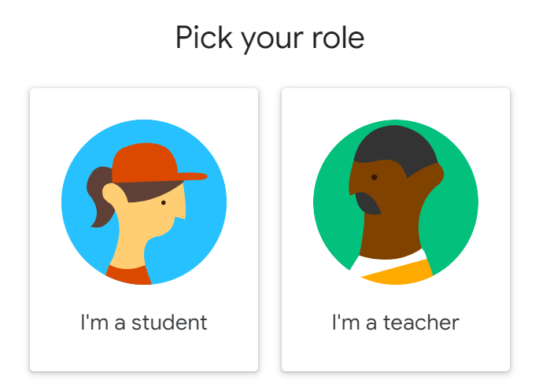

Any problems, please do not hesitate to contact the school office.

